|  |  |
| --- | --- |
| COURSE | BDSE |
| QUALIFICATION NAME | BDSE |
| MODUL NAME | PROGRAMMING FOUNDANTIONS |
| ASSIGNMENT | ASSIGNMENT 1 |
| ISSUE DATE | 21-DEC-22 |
| SUBMISSION REVISE DATE | 11-JAN-2023 |

TABLE OF CONTENT

* 1. Introduction……………………...................................................................3-14
  2. Types of Programming paradigms……………………………………………………………………14-19
  3. Programming paradigms use to make a project & example…………………………….19-21

2.1 5 features available to use Eclipse IDE to build the Application & example…………21-24

2.2 Explain about using IDE and without IDE……………………………………………………………25-39

Reference………………………………………………………………………………………………………………….40

Task 1.1 :

My name is Syavira Rizki Ariani,I just started a new role as a Junior Software Developer at a AQ Digital Solutions (AQDS). AQDS are independent software develop team as a software solution of all sizes and variety industries. And I am so excited to begin this new role and contribute the team. Cause This allows us to be flexible and adaptable in our approach to software development and solve the program has been requested by the client itself.

AQDS (AQ Digital Solutions) company has been approached by a small (Local Company) it is North Sussex Judo that specializes which providing training sessions to members of the local community. Regardless from of their level of experience.they cater to people of all ages and skill levels (expert to beginner), and committed to provide high quality judo training for the people who has interested for it. North Sussex Judo Company, their has make a strong to built a local community which is the North Sussex Judo it self has a loyal for the costumer base of people who had interested about the judo and always for comitte to improve their skills and abilities.

As a Result from approach the North Sussex Judo And we are as a junior software developer from AQDS so interested to potentially work with north sussex judo and making a solutions and their goals by developing costumized software solutions. North Sussex Judo has been requested program that calculate the cost of training fees for their athletes each months.. And North Sussex Judo currently have six atheletes enrolled on their training program, but they would like the ability to register more. For making an easier in this program. I will make the application for the athletes or the members that comfortable to access it, and will help for join the training that they want it. And also need to design interface more like understable and make everybody understood for that. Before to begin with the making program, we must discussed about to the client what are they need.

In this project after we discussed, we found a difficulities maybe as a we don’t know who are going and how many to sign the training later,because it is unpredictable,and much more people who joined, and we need and give some effort to reach out the goal which is I mention to automate registration and training cost calculation. For reach out this goal we have few points requirements must be added to this project.

1. functional requirements : are the requirements given by the client as North Sussex Judo. A few features do the client want to be use in a software.They are also called system behaviour.

* The data input for this program included the athlete’s name, training plan, current weight in kilograms,competition weight category, the number of competitions entered this month and the number of hours of private coaching.
* Calculation method for determine the total costing of training and competitions for the each months could depend of the specific price and billing. We need it to accurately calculate the total cost.
* And the program should also be able to give this following output:
* The athlete’s name
* An itemized list of all costs for the month
* The total cost of training and competitions for the month
* How their current weight compares to their competition weight category.

This information needed to the user through some form of the user interface.

1. Business Requirements : Basically for the Client Company. And get benefits in this software/program, and make automate the registration of process,reduce time, registrer more atheletes efficiently, etc.

* This Program make able to calculate the cost of training fees for atheletes each month.
* Make a simple program to use and understanding.
* The AQDS environments will to attend and code standards.
* This program can be flexible to use by user/people of all ages,skills, and making the experience for expert to beginner.
* Easy to handle any variety of different training plans and pricing structures.

TRAINING PLAN

|  |  |
| --- | --- |
| **Training Plan – Prices ($USD)** | |
| Beginner (2 sessions per week) – weekly fee | $25.00 |
| Intermediate (3 sessions per week) – weekly fee | $30.00 |
| Elite (5 sessions per week) – weekly fee | $35.00 |
| Private tuition – per hour | $9.00 |
| Competition entry fee – per competition | $22.00 |

|  |  |  |
| --- | --- | --- |
|  | **Weight Categories** | |
| Categories |  | Upper Weight Limit(Kg) |
| Heavyweight |  | Unlimited(over 100) |
| Light-Heavyweight |  | 100 |
| Middleweight |  | 90 |
| Light-Middleweight |  | 81 |
| Lightweight |  | 73 |
| Flyweight |  | 66 |

* Easy to handle multiple athletes at once
* Make easier to produce a report or invoice detailing for the cost each athlete.
* Easy to handle any additional fees, such as a private coaching fees.
* This program will be able to store data for each athelete, including their name, planning,and weight.

1. Non-functional Requirements are basically system properties. Like what abilities does the software have. The Software must be :

* Performace : this program can be easy to handle a large number of each atheletes and calculation without performance issues.
* Scalability : this program can be able to handle escalating the number of atheletes and compute as the company grows.
* Security : This program must store and handle which is sensitive personal and financial data in a secure manner in accordance with relevant laws.
* Usability : This program can be easy to use and understand for users/each atheletes of all ages and levels.
* Realibilty : this program must be able to handle unpredictable/error input or situations without crashing.

1. Environment requirements :

* Software: Determine the requirements and conditions of the software resources that must be installed on the computer to ensure optimal operation of the application.
* Application Software: This is the most common type of computer software and can be defined as an end-user program that helps in carrying out a project or achieving a desired result. The end user is the person who actually uses the product/application. Some examples of software include word processing programs such as Microsoft Word, etc. has many options and users can choose the one that suits their needs, budget and expectations.
* System software: Helps the user, computer or mobile device and the application to work seamlessly. This makes system software essential for the operation of any application software as well as the entire computer system. software: software designed for end users and system software for mobile computing devices, programming is a computer programmer and programmer who writes code. It's useful to think of these programs as a kind of translator. They take programming languages ​​like Python, C++, etc. and translate them into something a computer can understand.
* Driver Software: This software is often considered as system software. The driver software controls and manages devices connected to the computer. These drivers allow the device to perform necessary functions.

design tools: ms Powerpoint/doc.

MS PowerPoint is a program included in the series of Microsoft Office. It is used to create presentations for personal and professional purposes. There are several features in MS PowerPoint that can customize and enhance a presentation: ·

* Chart Layout There are several options and layouts on which the presentation is based. This option is available in the home section and one of the many layout options offered can be selected. The following figure shows the different slide options available for use.

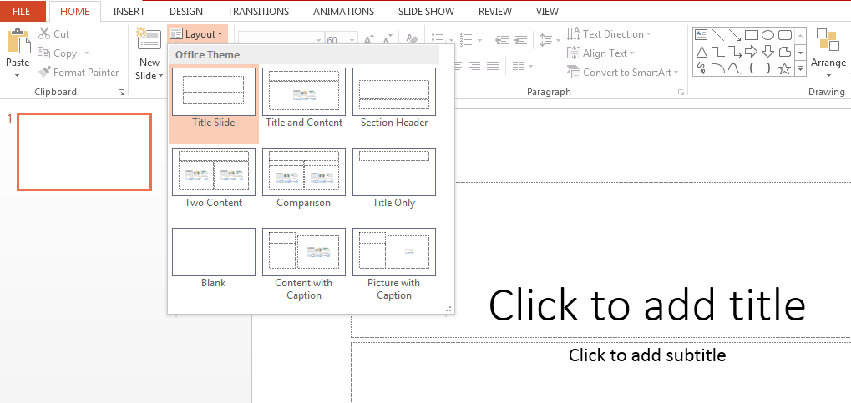

* Import - Images, Video, Audio and more. Under the Input category, there are several options for choosing which function to include in the presentation. This can include images, audio, video, header, footer, icons, shapes and more. The following image shows the functions that can be included:



* Slide design MS PowerPoint has different themes that allow you to add background colors and themes or texts to the slide. This makes the show more colorful and attracts the attention of the audience. This feature can be added through the "Design" category mentioned on the home page of MS PowerPoint. Although there are already existing design patterns, if one wants to add a new texture or color, there is also an option to customize the design. Moreover, slide designs can also be downloaded online. To design slides, see below

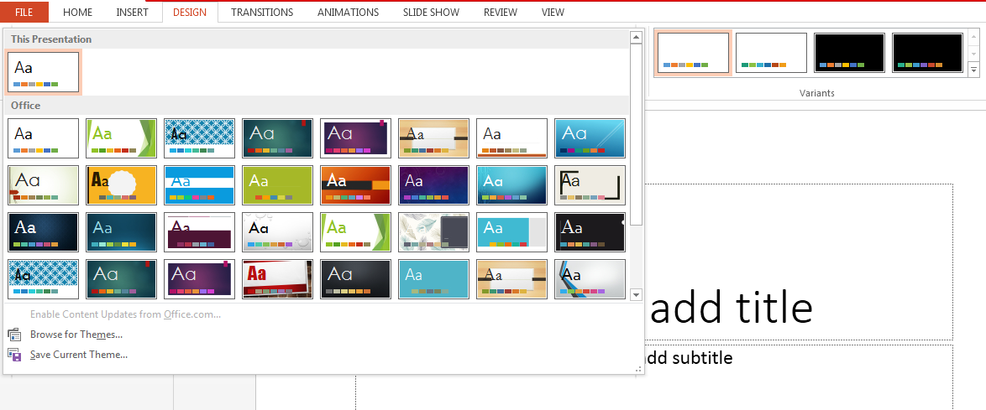

* Animations During a slide show, slides appear one after the other on the screen. If you want to add some animations to your slide presentation, you can refer to the Animations category. Different styles of animations available in PowerPoint, Apart from all these options; Font size, font style, font color, word art, date and time, etc. can also be added to PPT

Microsoft word :

Microsoft word is a word processor software developed by Microsoft in 1983. It is the most commonly used word processor software. It is used to create professional quality documents, letters, reports, resumes, etc and also allows you to edit or modify your new or existing document. The file saved in Ms Word has .docx extension. It is a component of the Microsoft Office suite, but we can buy it separately and is available for both Windows and macOS. We can using a few features to perform different types of operations on your documents, like we can create, delete, style, modify, or view the content of your document :

**1. File**

It contains options related to the file, like New(used to create a new document), Open(used to open an existing document), Save(used to save document), Save As(used to save documents), History, Print,  Share, Export, Info, etc.

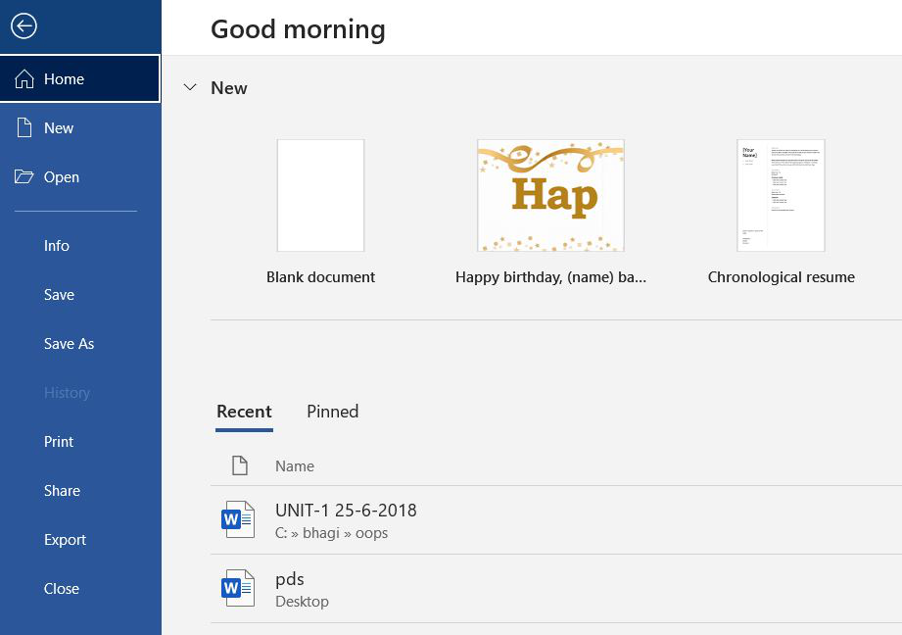

**2. Home**

It is the default tab of Ms Word and it is generally divided into five groups, i.e., Clipboard, Font, Paragraph, Style and Editing. It allows you to select the color, font, emphasis, bullets, position of your text. It also contains options like cut, copy, and paste. After selecting the home tab you will get below options:

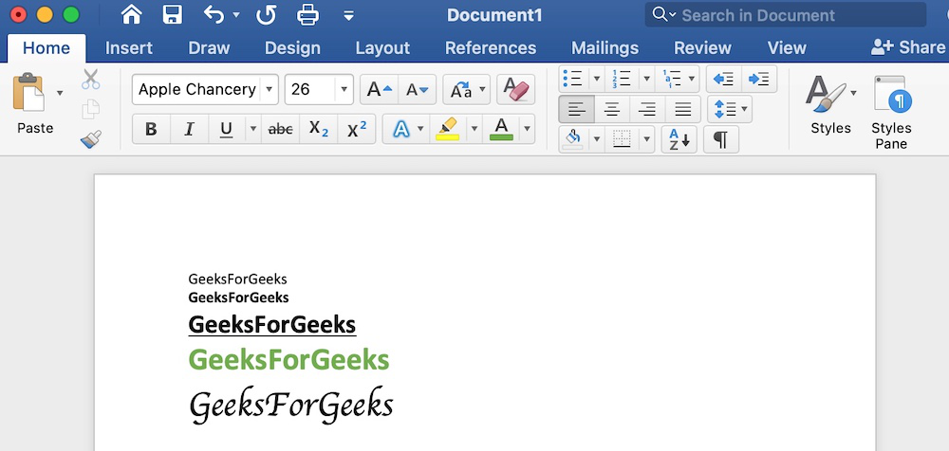

**3. Insert**

It is the second tab present on the menu bar or ribbon. It contains various items that you may want to insert into a Microsoft word. It includes options like tables, word art, hyperlinks, symbols, charts, signature line, date and time, shapes, header, footer, text boxes, links, boxes, equations, etc., as shown in the below image:

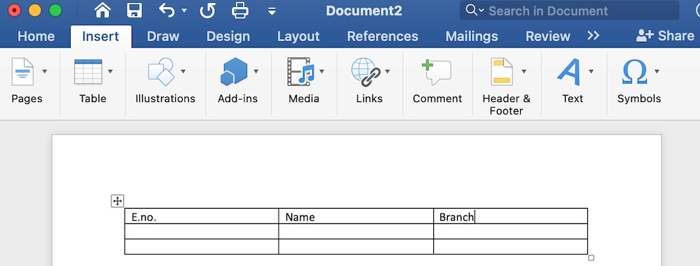

**4. Design**

It is the fourth tab present in the menu bar or ribbon. The design tab contains document designs that you can select, such as documents with centered titles, offset headings, left-justified text, page borders, watermarks, page color, etc., as shown in the below image:

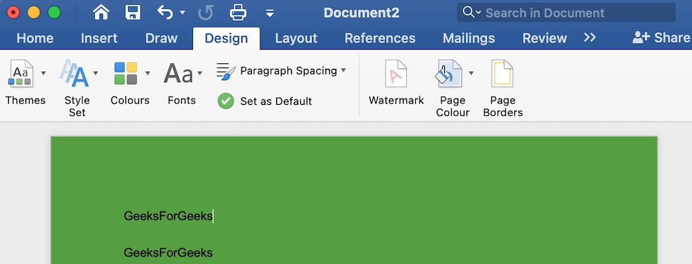

**5. Layout**

It is the fifth tab present on the menu bar or ribbon. It holds all the options that allow you to arrange your Microsoft Word document pages just the way you want them. It includes options like set margins, display line numbers, set paragraph indentation, and lines apply themes, control page orientation and size, line breaks, etc., as shown in the below image:

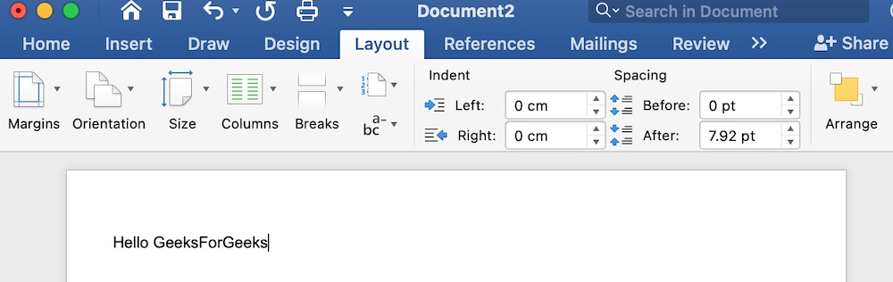

**6.References**

It is the sixth tab present in the menu bar or ribbon. The references tab lets you add references to a document, then create a bibliography at the end of the text. The references are generally stored in a master list, which is used to add references to further documents. It includes options like, Table of Contents, Footnotes, Citations & Bibliography, Captions, Index, Table of Authorities, smart look, etc. After selecting References tab, you will get the below options:

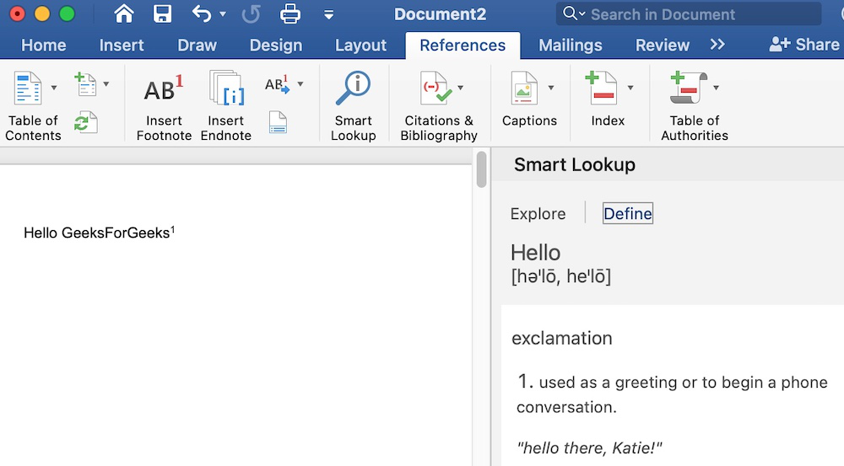

IDE: Eclipse What is an IDE? : IDEs are software development tools that developers use to simplify their programming and design experience. IDEs have a built-in user interface that brings together everything a developer needs to write easily. The best IDEs have features that allow developers to write and edit code editors, debug code with a debugger, compile code with a code compiler, and automate some software development projects.

Standard IDE Features:

• Text Editor: Almost all IDEs offer a text editor designed specifically for writing and modifying source code.

• Debugger: Debugging tools help developers identify and fix errors in source code.

• Compiler: The compiler feature in an IDE helps programmers translate programming languages ​​into machine-readable languages ​​such as binary code.

• Code Completion: This feature helps developers intelligently and automatically complete common code and components. This process helps the developers to save time and reduce errors caused by errors.

For example, the best IDE is Eclipse:

¬ Eclipse is a cross-platform tool with a powerful user interface that supports drag and drop.

¬ Eclipse IDE is also loaded with some important features like static analyzers, debugging and profiling features.

¬ Eclipse is friendly to enterprise development, allowing developers to easily work on scalable, open source software.

¬ Eclipse is best associated with Java, it also supports multiple programming languages. In addition, users can add their favorite plugins to the IDE to help with software development.

Language Ability: OOPS Computers are powerful machines. With a computer we can calculate numbers very quickly and create many amazing applications for use. But to use this power, we need to communicate with the computer using something less painful than manually typing ones and zeros. OOP aims to solve this problem by allowing developers to break down elements into smaller, more manageable objects that can be developed and tested separately. This not only simplifies the development process but also adds scalability to the project

Object Oriented Programming Language As we know:

Java

Java is the leading OOP language OOP Java is one of the most used and requested languages. Java's motto is "write once, run anywhere," and this is reflected in the number of platforms it runs on. We can use Java for software, games and support etc. Object-oriented programming in Java shares the same fundamentals as other OOP languages.

Python

Python is an object-oriented programming language with strong roots in machine learning, artificial intelligence, and data science. It is also a versatile and beginner-friendly language with a syntax often compared to English. In Python, OOP greatly contributes to code reuse. This allows developers to maintain and manage code in less time.

C++

C++ is a superset of C, which means it has the speed of C, but with additional functionality. C++ is known to be a compiled, reliable and productive language. It is even used to create compilers and interpreters for other languages. Object-oriented programming in C++ facilitates a smoother and more efficient development process.

Ruby

Ruby is another OOP language designed for simplicity. That being said, Ruby is an incredibly powerful language. The creator of the ruby, Yukihiro "Matz" Matsumoto, said, "The ruby ​​looks very simple, but inside it is very complex, just like our human body." It is commonly used with Ruby on Rails to create dynamic applications.

C#

C# is an object-oriented programming language developed by Microsoft. It is designed to enhance existing concepts in C. C# supports the Microsoft .NET framework along with many web applications, games, desktop applications, and mobile applications. Some of the most common OOP concepts in C# are encapsulation, inheritance, and polymorphism.

PHP

PHP is an OOP language that is considered a server-side scripting language. PHP can be embedded in HTML and used to create dynamic websites. PHP, which stands for Hypertext Preprocessor, is also one of the easiest programming languages ​​to learn. But note that PHP does not support all object-oriented features such as multiple inheritance.

TypeScript

TypeScript is a JavaScript superset with static typing. It is designed to help developers launch scalable projects and web applications. Because TypeScript builds on the concepts of JavaScript, another language that supports OOP functionality, it can be said that TypeScript is somewhat object-oriented.

JavaScript

JavaScript is object-oriented, but it is not a class-based language like most OOP languages. This can be confusing because classes are supposed to be one of the main features of OOP. However, there is no standard specification that a language must be OOP, as long as it uses an object-oriented model and supports modularity and code reuse. According to most developers, JavaScript meets these criteria. Technically, JavaScript is a prototyping language, which is an OOP style. Instead of using classes to define objects, object-oriented programming in JavaScript allows you to use and reuse constructor functions.

Hardware : machine The most common set of requirements defined by any operating system/software aplplication is the physical computer resources,also known as hardware, a hardware requirements list of often accompanied by a hardware compability list, especially in case of operating systems.

Architecture All computer operating systems are designed for a particular computer architecture. Most software applications are limited to particular operating systems running on particular architectures. Although architecture-independent operating systems and applications exist, most need to be recompiled to run on a new architecture. See also a list of common operating systems and their supporting architectures.

Computer Power Central

Processing Unit (CPU) power is the main system requirement for any software. Most software running on the x86 architecture defines processing power as the model and clock speed of the CPU. Many other CPU characteristics that affect speed and performance, such as bus speed, cache memory, and MIPS, are often overlooked. This definition of performance is often inaccurate, as AMD Athlon and Intel Pentium CPUs often have different transfer speeds at similar speeds. Intel Pentium CPUs are very popular and are often mentioned in this category.

memories. All software, when it runs, resides in the computer's random access memory (RAM).

Storage requirements are determined by taking into account the needs of the application, operating system, software and support files, and other running processes. The definition of this requirement also takes into account the optimal performance of other related software running on a multi-threaded computer system.

second warehouse. Data storage device requirements vary, depending on the size of software installation, temporary files created and maintained while installing or running the software, and possible use of swap space (if RAM is insufficient).

Display adapter. Software requiring a better than average computer graphics display, like graphics editors and high-end games, often define high-end display adapters in the system requirements. Peripherals Some software applications need to make extensive and/or special use of some peripherals, demanding the higher performance or functionality of such peripherals. Such peripherals include CD-ROM drives, keyboards, pointing devices, network devices, etc.

**Task 1.2**

Object-oriented programming (OOP) is a computer programming model that organizes software design around data, or objects, rather than functions and logic. An object can be defined as a data field that has unique attributes and behavior. (Gillis, n.d.)

So on this flowchart I try to represent the OOP implementation and also the procedural of the system program.

A. Procedural Programming Paradigm

Procedural programming is a programming paradigm, derived from imperative programming, based on the concept of the procedure call. Procedures (a type of routine or subroutine) simply contain a series of computational steps to be carried out. Any given procedure might be called at any point during a program's execution, including by other procedures or itself. (Lavender, 2022‎ ). This paradigm emphasizes on procedure in terms of under lying machine model. There is no difference in between procedural and imperative approach. It has the ability to reuse the code and it was boon at that time when it was in use because of its reusability.

|  |
| --- |
| Advantages of procedural programming : |
| * The procedural programming languanges are relatively much easier to learn as first programming language for the beginner |
| * The straight forward program organization makes it deal choice as general purpose language |
| * The procedural programming such as C language is still being used for many application |
| * The C language has extensive library of function suitable for various application. |
| * The use of standard library functions bring down significant reduction in the overall development cost and time. |
| * The concept of pointers in the procedural programming C language allows level memory operations |

|  |
| --- |
| Disadventages of procedural programming : |
|  |
| * The procedural programming not suitable for large and complex software project |
| * It is difficult to represent the real world objects realistically in the procedural programming |
| * It is difficult to protect the data from inadvertent change since most data is generally global leading to the problem of spaghetti code |
| * The software maintenance is relatively difficult for a procedural programming software |
| * For procedural programming paradigm, the function most important component of the program and the data doesn’t get the due attention. |
|  |

Example of procedural programming paradigm :

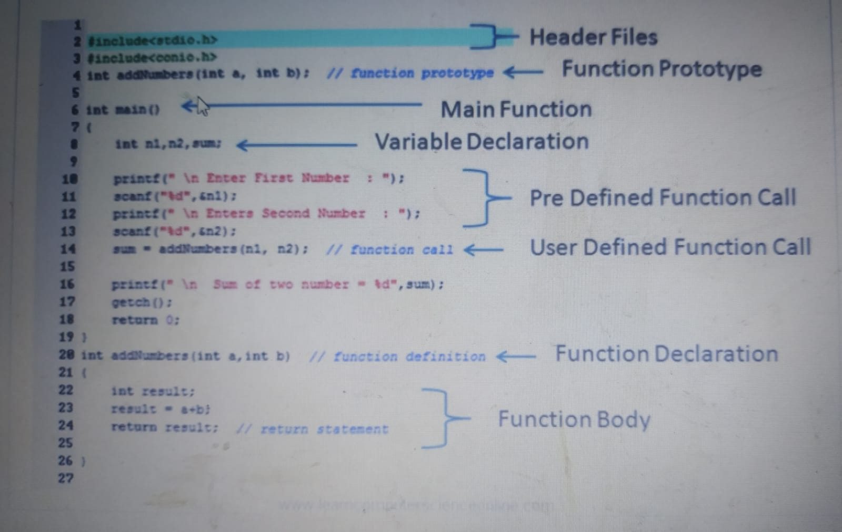

B. Object Oriented Programming Paradigm

Object-oriented programming (OOP) is a programming paradigm based on the concept of "objects", which can contain data and code: data in the form of fields (often known as attributes or properties), and code, in the form of procedures. (Nythar, 2022). A program is written as a collection of classes and objects that are designed to communicate. The smallest and most basic thing is an object, and all calculations are done only on objects. Emphasis is placed on data rather than methods. It can solve almost all real world problems faced in today's scenarios.

Advantages:

• Reusability. Code reuse is at the heart of object-oriented programming. Because of polymorphism and abstraction, you can create a function that can be reused. You can also copy data and functions that are already written using inheritance. This saves time and reduces complexity.

• Parallel development. There is enough groundwork for the parts of the program to be developed separately and to work according to object-oriented principles. This makes concurrent development much easier for larger development teams.

• Maintenance. OOP code is much easier to maintain. Instead of individually debugging hundreds of different instances where a function is called, you can debug a modular and polymorphic function. This is the main advantage of OOP. Security. Object oriented languages are often favored because of their built-in security features. With encapsulation, you bind data to functions, which limits access to data. Unless specified, other methods and classes cannot access private data by default.

Modularity. Object-oriented programming languages ​​divide the program into objects and classes. This is a major advantage of object-oriented programming because it gives your application a more modular structure. Modular code is easier to read, write and maintain.

Disadvantages of Object-Oriented Programming Languages ​​ Although OOP languages ​​are powerful, they are not necessarily useful in all situations. Therefore, knowing what and how to code remains a priority. This list highlights some of the disadvantages of object-oriented programming that you should consider.

• Often chaotic. Because object-oriented languages ​​are so customizable and scalable, it's easy to lose track of what code is doing. OOP code can work in many different ways. There are many programming techniques in OOP that don't work well with other techniques, are inefficient, and difficult to use.

• Requires more planning. OOP languages ​​are modular. So going in without a clear plan is a recipe for disaster. Creating an effective program requires a solid plan more than any programming paradigm.

• Transparency. This is an advantage and a disadvantage. Objects and functions can work independently of each other. They can absorb information and usually give reliable results. As a result, they can become black boxes, which means it is not always clear what they are doing.

• Activity. Object-oriented languages ​​often suffer from performance degradation. Programs written in OOP languages ​​are often larger and require more computation to run than functional languages. However, this is not always true and important. For example, C++ is an OOP language, but it is one of the fastest languages ​​available. The difference in performance becomes apparent only when overclocking is required.

Example program of OOP :

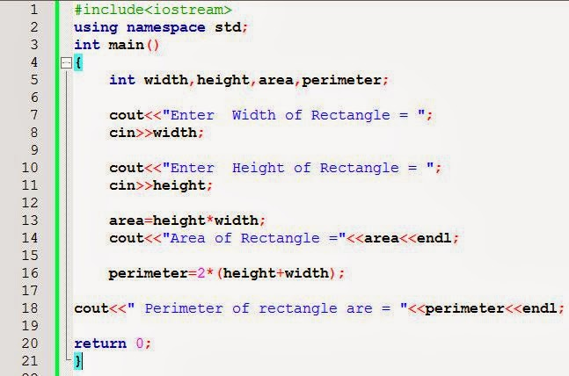

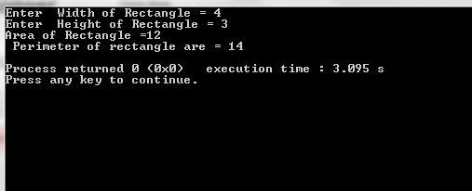

C. Event Driven Programming Paradigm

In computer programming, event-driven programming is a programming paradigm in which the flow of the program is determined by events such as user actions (mouse clicks, key presses), sensor outputs, or message passing from other programs or threads. Event-driven programming is the dominant paradigm used in graphical user interfaces and other applications (e.g., JavaScript web applications) that are centered on performing certain actions in response to user input. This is also true of programming for device drivers (Torte, 2022). This programming methodology is based on data and its movement. Program statements are defined by data rather than hard-coding a series of steps. A database program is the heart of a business information system and provides file creation, data entry, update, query and reporting functions. There are several programming languages that are developed mostly for database application. For example SQL. It is applied to streams of structured data, for filtering, transforming, aggregating (such as computing statistics), or calling other programs. So it has its own wide application.

Advantages of Event-Driven Programming

1. Flexibility

Programmers that use event-driven can be altered easily if the programmer wants something to be changed. This paradigm allows the programmer to produce a form of their requirements.Programmers who are event-driven can be put together without too many problems and also the code and design can be easily altered because if something isn't right.

2. Suitability for Graphical Interfaces

Event-driven allows the user to select different tools from the toolbar to directly create what they need such as buttons, radio buttons, etc.

This also allows people to put objects where they want them and can directly edit. Some people find it easier to directly click on the thing they want to edit.

3. Simplicity of Programming

Event-driven can make programming easier for some by being able to directly edit the object you want the code for.

Another thing that can make the programming easier is that when using an event driven language such as visual basic it usually has predictive coding so when the user is coding it will predict what you want to do from what you are typing.

4. Easy to Find Natural Dividing Lines

it is easy to find natural dividing lines for unit testing infrastructure.

5. Highly Compostable

It is highly compostable.

6. Simple and Understandable

It allows for a very simple and understandable model for both sides of the DevOps Bridge.

7. Purely Procedural and Purely Imperative

Both purely procedural and purely imperative approaches get brittle as they grow in length and complexity.

8. A good way to Model Systems

It is one good way to model systems that need to be both asynchronous and reactive.

9. Allows for more Interactive Programs

It allows for more interactive programs. Almost all modern GUI programs use event-driven programming.

10. Using Hardware Interrupts

It can be implemented using hardware interrupts, which will reduce the power used by the computer.

11. Allows sensors and other hardware

It allows sensors and other hardware to easily interact with software.

Disadvantages Event-Driven Programming

1. Complex

For simple programs, event-driven programming is often more complex and cumbersome than batch programming.

2. Less Logical and Obvious

The flow of the program is usually less logical and obvious

3. Difficult to find Error

Errors can be more difficult to spot than with simpler, procedural programs.

4. Slower

Programs with complex GUIs may be slower to load and run than simpler programs particularly if RAM is insufficient.

5. Confusing

Programs with too many forms can be very confusing and/or frustrating for the user

6. Tight Coupling

Possible tight coupling between the event schema and the consumers of the schema.

7. Blocking

Reasoning about blocking operations might be becoming more difficult.

Example of Event Driven Paradigm :

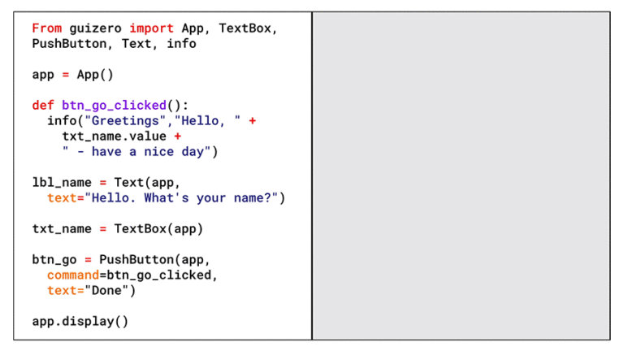

**Task 1.3**

The programming paradigms I used in this project.

1. Object Oriented Programming (OOP) paradigm.

I have used object-oriented programming paradigm because I have created an object which has its own state which is only modified by built in procedures and in this case that is a Student class that I have created.

2. The Functional Programming paradigm

I've been using the functional programming paradigm because I've created a calculation that calculates the results of a test that students/examinee will take.

**The implementation & example will be used :**

-classes

Classes in object oriented programming serve as the blueprint for the entire structure of the code. Classes are data types that are defined by the developer. It can be viewed as one of the most crucial fundamentals of object oriented programming. An OOP class is a template that can be used to create objects, provide values to attributes, and implement methods or functions. Example of creating a java class for storing the main/important data:

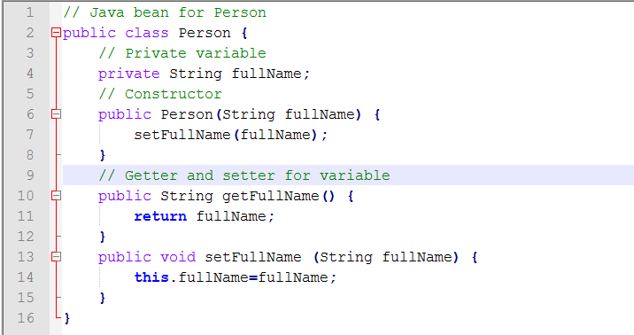

-Objects

In this type of programming, an object is an instance, or a variation, of a class with clearly-assigned data. If you were to set the class to ‘animals’, an example of an object that would serve as an instance would be ‘cat’. An object can be attributed to real-world items or abstract entities. Examples of creating an object of Student class:

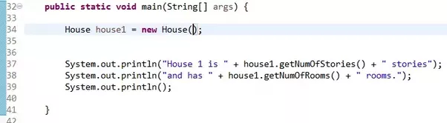

-Methods

Object oriented programming methods are procedures related to classes. They describe the behavior of an object. Put simply, a method is an action that an object can perform. A ‘person’ class could have methods like ‘eating’ or ‘singing’. An object oriented programming method is often compared to a function but they differ in that the latter is task-based. Example of a method with params and nested methods

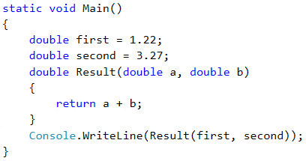

Task 2:

Task 2.1

Here is the 5 features that essential and useful in Eclipse.

1 Code Suggestion

Code suggestion is a feature that suggests possible completions for code as you type, based on the context of your code and the language you use. It can help you write code faster by reducing the amount of typing you have to do, and it can also help you avoid syntax errors by suggesting valid code snippets. For example, if you are typing a line of code and need to access a particular object or method, the code suggestion feature might offer suggestions for object or method names that are valid in the context of your code. This can be especially useful if you are working with a language or framework that has a lot of objects, methods, or functions, as it can help you quickly find and use the ones you need. Overall, code suggestion or autocompletion is a helpful feature that can save you time and effort while you are coding. You have to press the CTRL+Space in the same time to show the Template Proposals.

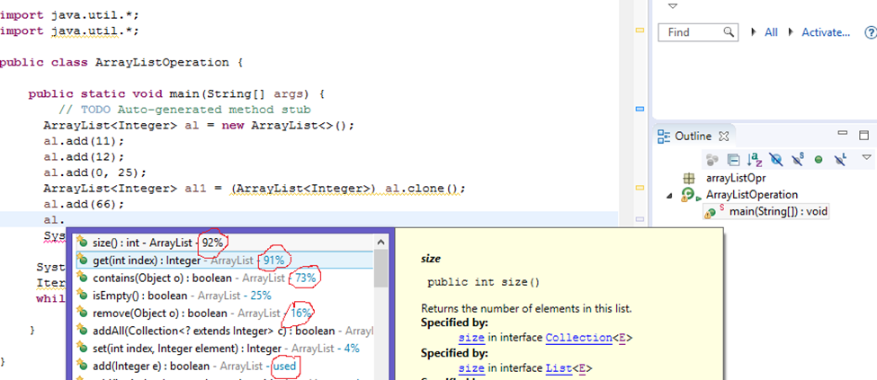

2. Error Highlight

Error highlight is a feature that highlights syntax errors and other issues in your code, making it easier to spot and fix problems. This can be a handy feature, especially when working on a large or complex codebase. It can help you quickly identify and resolve issues that might otherwise be difficult to find. Some code editors and IDEs will highlight errors in real-time as you type, while others may require you to run a separate "linting" or "syntax checking" tool to identify issues. Either way, error highlighting is an important feature that can help you write cleaner, more reliable code. In addition to highlighting syntax errors, many code editors and IDEs also offer additional error-checking and debugging tools, such as the ability to trace the flow of control through your code or inspect the values of variables at different points in your program. These tools can be beneficial when trying to understand why your code is not working as expected.

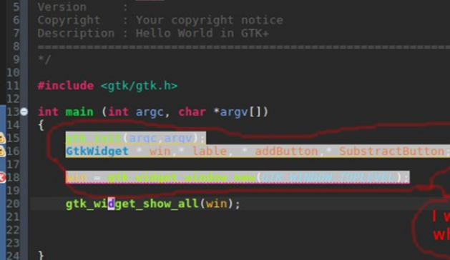

3. Debugging Debugging is the process of identifying and fixing errors in your code, and debugging tools are an essential part of this process. Debugging tools allow you to step through your code line by line, execute individual lines of code, and inspect the values of variables at different points in your program. This can be extremely helpful when trying to understand why your code is not behaving as expected, as it allows you to see what is happening inside your code at a deficient level. Many code editors and IDEs include built-in debugging tools or standalone tools designed to work with a specific programming language or environment. Some standard features of debugging tools can set breakpoints, step through code, inspect variables, and see the flow of control through your code. Overall, debugging tools are an essential part of the software development process, and they can save you a lot of time and frustration by helping you identify and fix errors in your code

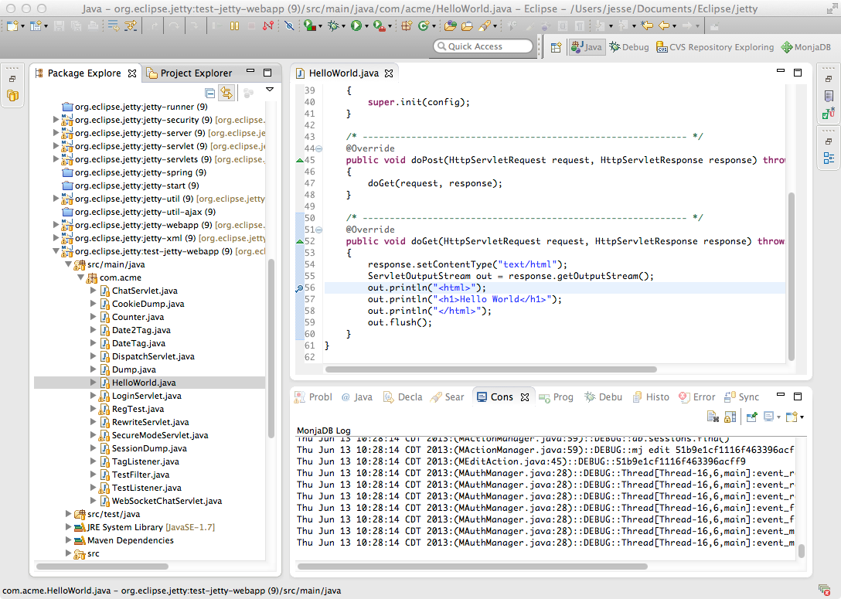

1. Syntax Color Highlights Syntax highlighting is a feature that changes the color of different parts of your code based on the language you are using. This can make your code easier to read and understand, as it helps visually distinguish between different code elements, such as keywords, variables, and functions. For example, in a language like Python, keywords like "if" and "for" might be highlighted in blue, while variables might be highlighted in green, and functions in purple. This can help you quickly identify different parts of your code and understand how they are related to each other. Syntax highlighting is often customizable, so you can choose the colors and styles that work best for you. Many code editors and IDEs include syntax highlighting by default, and you can usually customize the colors and styles to suit your preferences. Overall, syntax highlighting is a helpful feature that can make your code easier to read and understand, and it can be especially useful when you are working with large or complex codebases

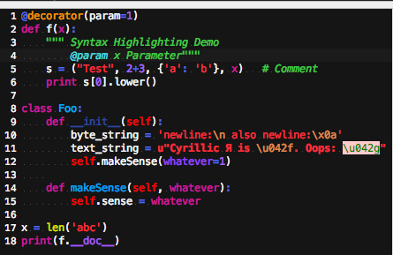

5. Refactoring

Refactoring in Eclipse includes a refactoring tool that allows you to safely and easily make changes to your codebase, such as renaming variables or moving code between files.

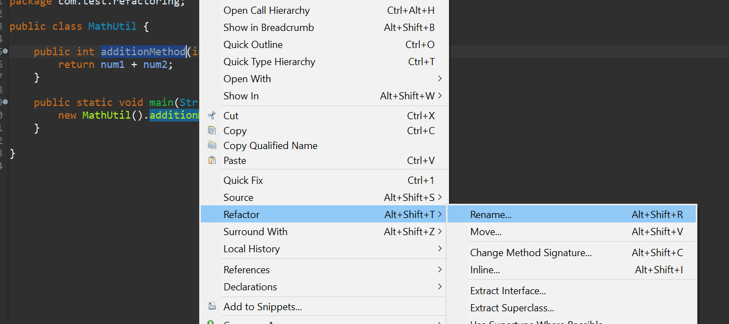

Task 2.2

Solution:

As I mentioned earlier regarding the features that are in the IDE, it is very clear that using it will be very helpful when writing code.

And also, IDE makes coding more efficient by providing support for syntax highlighting, code completion, project management, and much more

So if we don't use an IDE it will take a lot of time and our work will be very inefficient, considering we have to do everything manually, and if we miss something, we are never reminded about it.

|  |  |
| --- | --- |
| IDE | Non-IDE |
| ECLIPSE | Notepad, sublime,wordtext |
|  | CMD,JDK |
|  | Use CMD |
|  |  |

If we are using an IDE will be so simple and will manage us to create the code easier.

IDE :

Eclipse :

Eclipse is an integrated development environment (IDE) for Java and other programming languages like C, C++, PHP, and Ruby etc. Development environment provided by Eclipse includes the Eclipse Java development tools (JDT) for Java, Eclipse CDT for C/C++, and Eclipse PDT for PHP, among others.

Opening the New Java Project wizard

The New Java Project wizard can be used to create a new java project. There are many ways to open this wizard −

* By clicking on the File menu and choosing New →Java Project.
* By right clicking anywhere in the Project Explorer and selecting New → Java Project.
* By clicking on the New button (New Button ) in the Tool bar and selecting Java Project

## Using the New Java Project wizard

The New Java Project Wizard has two pages. On the first page −

* Enter the Project Name
* Select the Java Runtime Environment (JRE) or leave it at the default
* 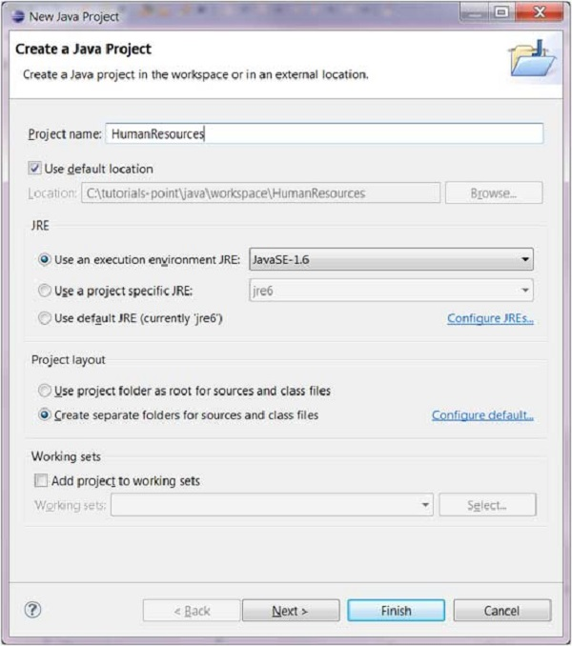Select the Project Layout which determines whether there would be a separate folder for the source codes and class files. The recommended option is to create separate folders for sources and class files.

You can click on the Finish button to create the project or click on the Next button to change the java build settings.

On the second page you can change the Java Build Settings like setting the Project dependency (if there are multiple projects) and adding additional jar files to the build path

Viewing the Newly Created Project

The package explorer shows the newly created Java project. The icon that represents a Project is decorated with a J to show that it is a Java Project. The folder icon is decorated to show that it is a java source folder.

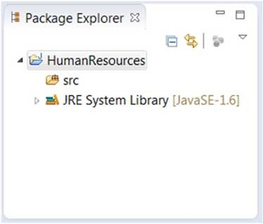

Create java package :

Opening the New Java Package wizard

You can use the New Java Package wizard to create a Java package. The Java Package wizard can be opened in different ways −

• By clicking on the File menu and selecting New → Package.

• By right click in the package explorer and selecting New → Package.

• By clicking on the package icon which is in the tool bar( ).

If you are creating a sub package, before opening the Java Package wizard select the parent package so that name field can have a default value in it.

Using the New Java Package Wizard

Once the Java Package wizard comes up −

• Enter/confirm the source folder name.

• Enter the package name.

• Click on the Finish button.

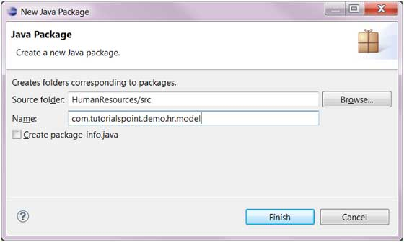

Viewing the Newly Created Package

The package explorer will show the newly created package under the source folder.

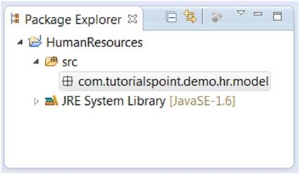

-create java class

Opening the New Java Class Wizard

You can use the New Java Class wizard to create a Java class. The Java Class wizard can be invoked in different ways −

* By clicking on the File menu and selecting New → Class.
* By right clicking in the package explorer and selecting New → Class.
* By clicking on the class drop down button (Drop Down Button ) and selecting class ( Class Button).

Before invoking the New Java Class wizard, if possible, select the package in which the class will be created so that the wizard will automatically populate the package for you –

• Make sure that the source and package directory are correct .

• Enter the name of the class.

• Select the appropriate class modifier.

• Enter a superclass name or click the Browse button to search for an existing class.

• Click the Add button to select the interfaces implemented by this class. • Check and change checkboxes for method notes and comments.

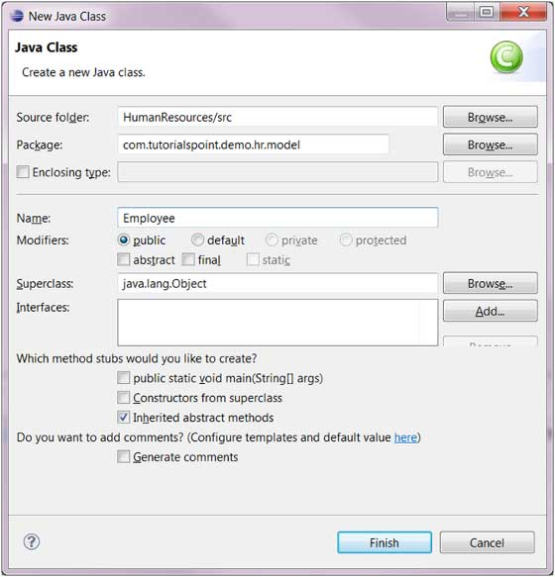

• Click the Finish button. Viewing the newly created Java class The newly created class should be closed in Explorer view and appear in an instance of the Java editor that you can use to modify the new class. It should appear in the editor area

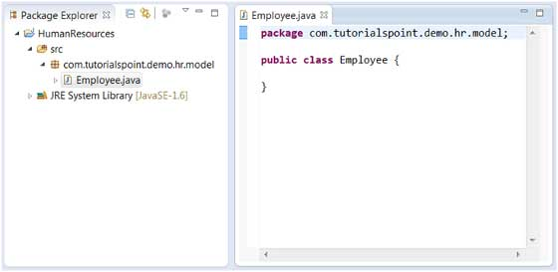

Non IDE :

Download JDK

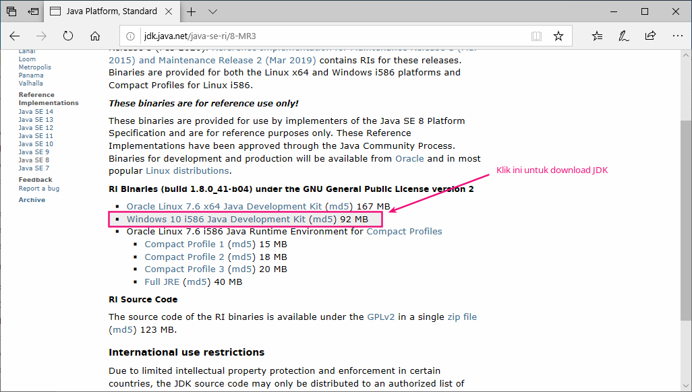

After that, we will get a ZIP file containing the JDK. Please extract this file

into **C:\Program Files\**.

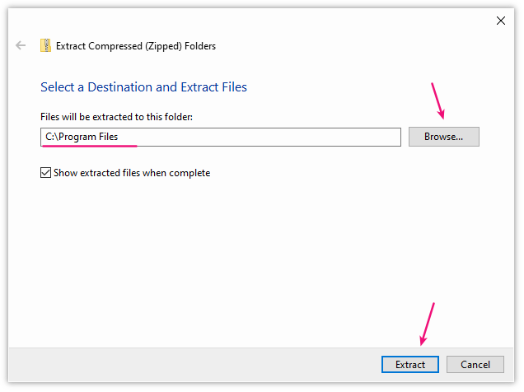

So now we will have a new folder, namely **java-se-8u41-ri**

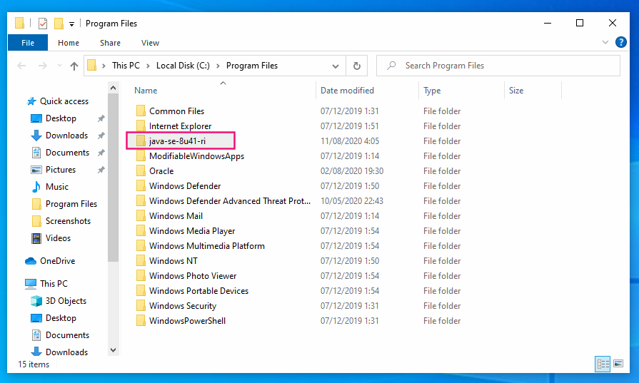

At this point, we actually have the JDK installed. However, it can't be used yet.

If you don't believe...

Try opening CMD and typing java or javac.

Then the result:

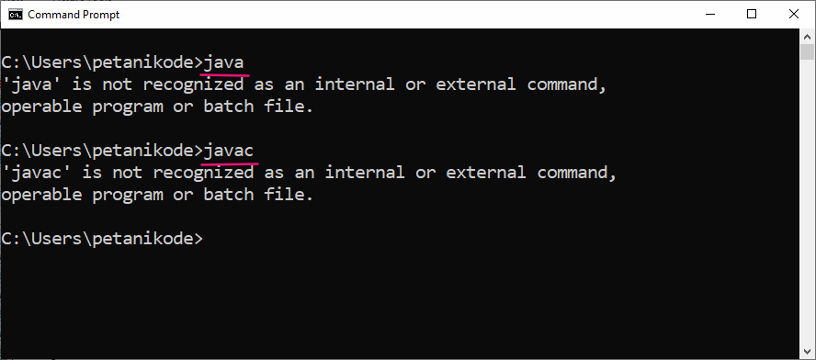

Command java and javaccannot be recognized in CMD yet.

The command javacfunctions to compile Java programs and javafunctions to run Java programs.

In order for these two commands to be recognized, we must register them in an *Environment Variable* .

Let's do it:

Please click Start Menu , then type env . Then it will appear like this:

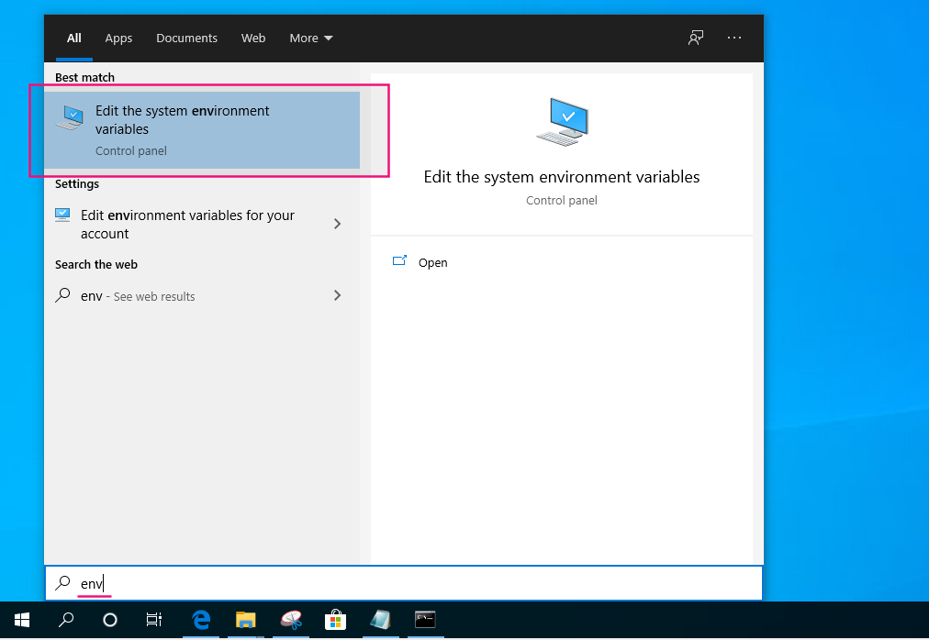

Please open the Edit the system environment variables program , so it will appear like this :

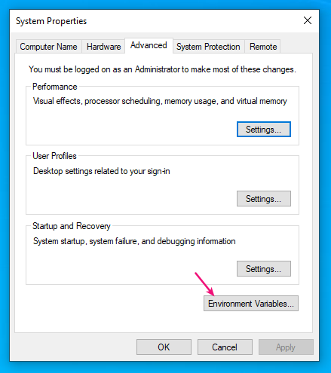

**Click Environment Variables , then in the window that appears click New**

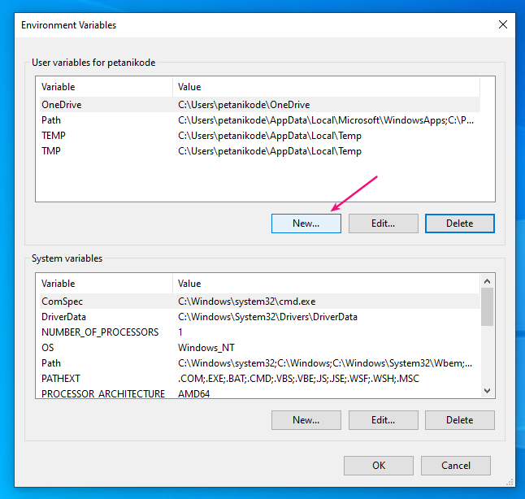

So it appears like this :

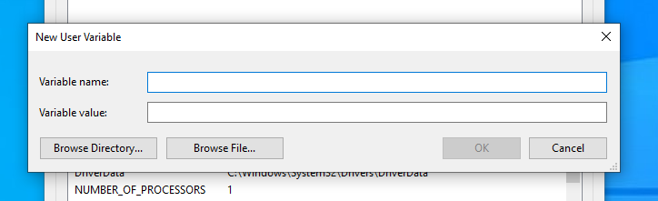

. Here we create a new variable called JAVA_HOME and the value is the JDK path address. The purpose of creating the variable is JAVA_HOME, so later the installed JDK is determined by Netbeans. Please open Windows Explorer and then navigate to the folder where we extracted the JDK earlier. Right-click on the address bar and then select Copy address as text

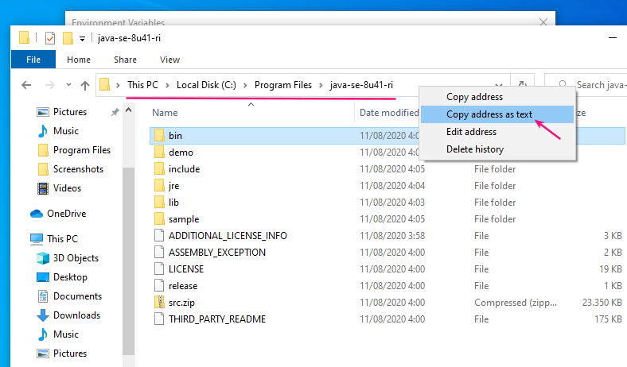

After that, go back to the variable creation window and *paste* the address into the value of the variable JAVA_HOME

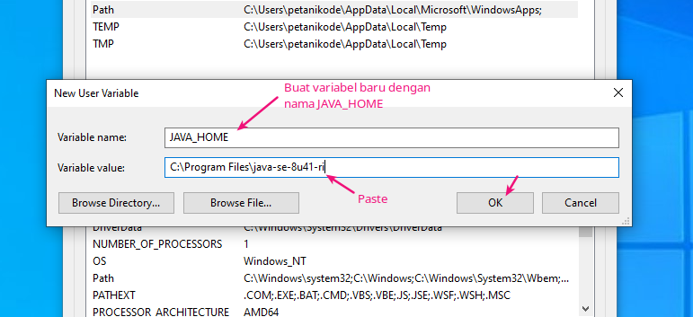

After that, we will have a new variable named JAVA_HOME. Next, please edit the variable Path.

Click the variable Paththen click the Edit button

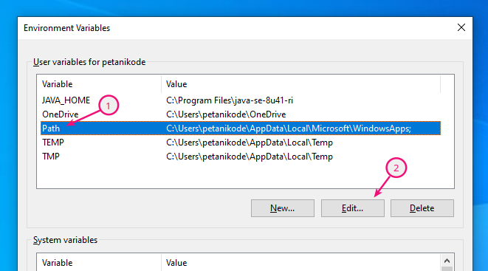

In the window that appears, click the **New** button and fill it with**%JAVA_HOME%\bin**

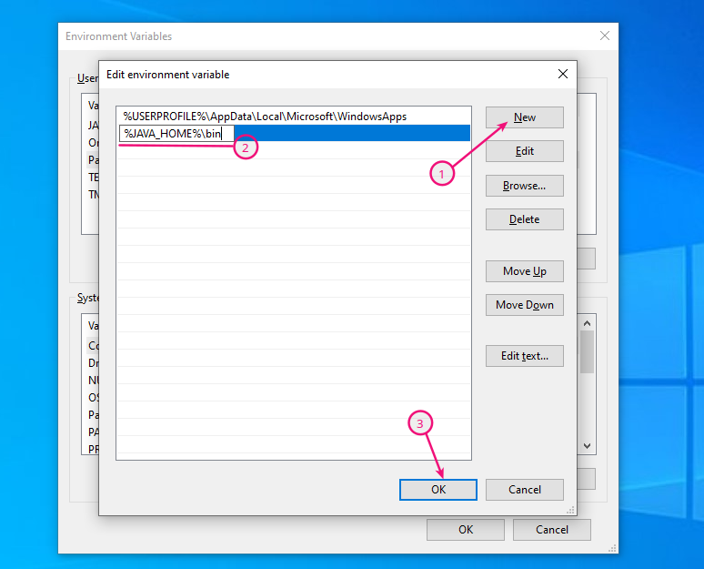

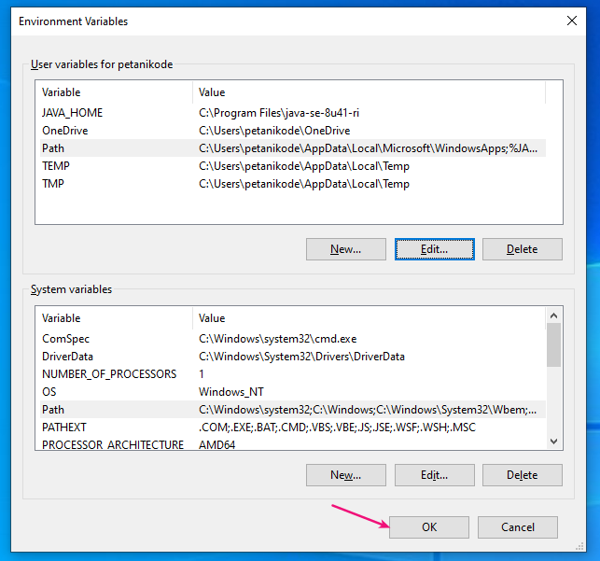After that, click OK to save all the variables that have been created

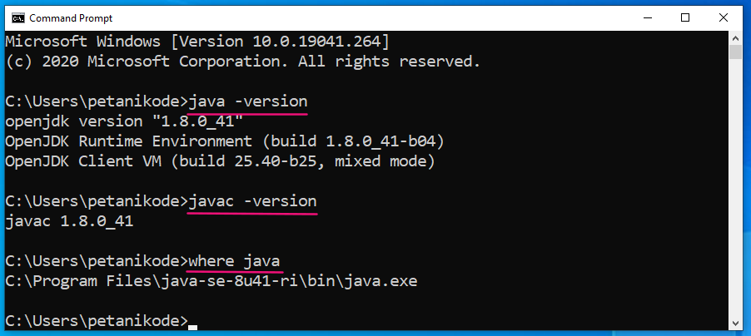Then the result:

**Experiment Making Hello World Program**

To make sure the JDK is installed correctly, let's try it by creating a **HelloWorld** program .

Please open Notepad, then type the following program code:

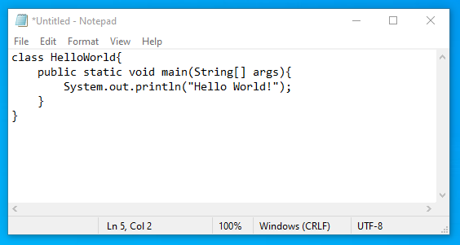

After that, save it in the **Documents** folder with the name **HelloWorld.java**.

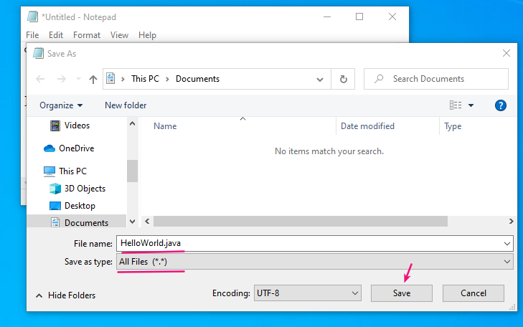

Next, we will *compile* the program.

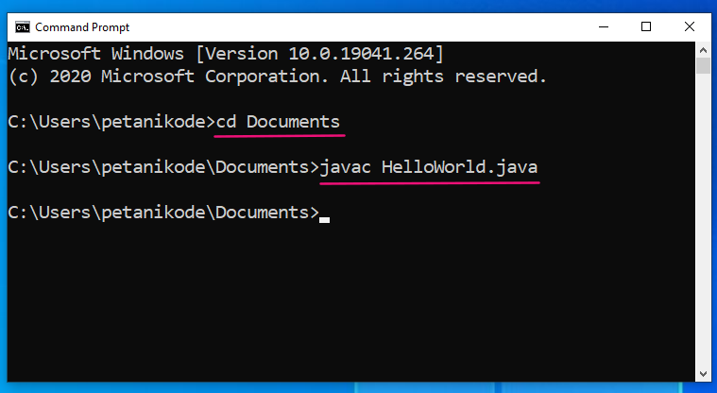

Now, we have a new file in the **Documents** folder named **HelloWorld.class**. This file is a compiled result from a Java program **HelloWorld.java**

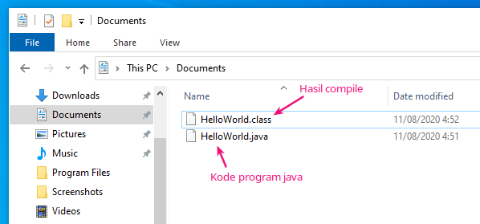

Next, return to CMD and type the following command to execute the program

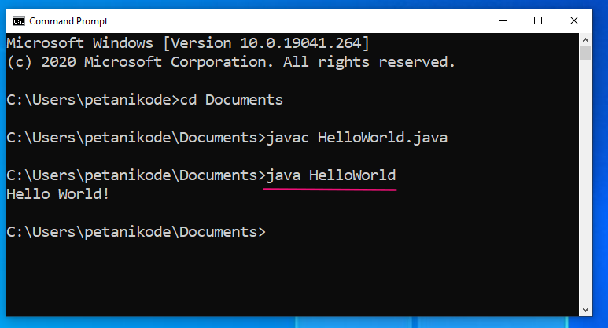Then the result:

[1] <https://careerkarma.com/blog/object-oriented-languages/#:~:text=Java%2C%20Python%2C%20C%2B%2B%2C,programming%20languages%20in%20the%20world>.

1. <https://www.geeksforgeeks.org/computer-science-projects/?ref=sh>

   <https://benchpartner.com/advantages-and-disadvantages-of-event-driven-programming>

   <https://www.petanikode.com/java-windows/>